November 7, 2022

Mr. Jed A. Brown
Board Chair
Webb County-City of Laredo Regional Mobility Authority
7917 McPherson Road, Suite 203
Laredo, Texas 78045

Dear Mr. Brown,

Thank you for the opportunity to provide consulting services to the Webb County-City of Laredo Regional Mobility Authority. TXP, Inc. was tasked with updating its 2018 feasibility study for a two-part Transportation Reinvestment Zones (TRZ) along Loop 20: 1) Loop 20 from US 59 to US 83, and 2) west from US 83 to the proposed Bridge #5. TXP has used a similar report format for the Loop 20 TRZ study to allow the RMA and stakeholders to compare the findings more easily. TXP’s tasks were grouped around three major tasks:

- Economic & Real Estate Assessment of the Loop 20 Area – TXP began by examining socioeconomic and real estate datasets. TXP also researched utility, easement, flood plain, and other issues that might impact or limit the development potential of this area. As part of this task, TXP contacted landowners about their plans for the area.

- Collect & Analyze Webb County Appraisal District Data – TXP analyzed GIS data and certified appraisal rolls from the Webb County Appraisal District. This information helped inform the taxable value of future residential and commercial properties with the Loop 20 TRZ.

- Establish a Loop 20 TRZ Preliminary Tax Revenue Forecast – TXP then created a forecast that will assist in determining if a TRZ is feasible and should be pursued. This initial forecast will need to be refined to match the ultimate boundary and duration of a Loop 20 TRZ.

Please do not hesitate to contact me with any questions or comments.

Best regards,
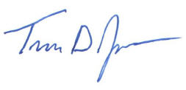
Travis D. James
Vice President

Loop 20 TRZ Area Economic and Geographic Context
The Webb County-City of Laredo Regional Mobility Authority (RMA) and the City of Laredo are interested in utilizing a portion of future ad valorem tax revenue to encourage and support economic development in south Laredo along the Loop 20 South corridor. This tax revenue would be used to financially support and accelerate the design and construction of overpasses along Loop 20 (Cuatro Vientos) between US 59 to US 83. If a TRZ is implemented along Loop 20, property owners will pay no additional property taxes.

Based on initial plans, the Loop 20 improvements would include five new overpasses as well a southern extension of Cuatro Vientos to US 83. Currently, Loop 20 terminates at Mangana-Hein Road. In addition, a potential Loop 20 TRZ would include the area west of Loop 20 from US 83 to the proposed Bridge #5. The new international crossing would serve as an alternative route for passenger vehicle, as well as tractor trailer traffic and help spur industrial and commercial development in the surrounding area, as well as possibly along the proposed corridor. TXP assumed this new bridge crossing would not open for 10 years.

Based on initial feedback from stakeholders, the proposed Loop 20 TRZ is divided into two components (see Figures 1 and 2):

- Loop 20 (Cuatro Vientos) from US 59 to US 83 and
- Cuatro Vientos west from US 83 to the proposed Bridge #5.

TXP began the analysis by creating a 1-mile buffer on each side of the Loop 20 alignment for a total width of two miles. TXP excluded all parcels north of US 59. As with past studies, if any portion of the buffer touched a parcel, the entire parcel was included in this analysis. This results in very large rectangular parcels being included.

Because TRZs capture future real property tax increment, the focus of any preliminary forecast should be on undeveloped areas that are likely to attract new residential and commercial construction over the next 10 to 20 years. However, transportation projects such as the contemplated Loop 20 improvements should have a positive impact on existing neighborhoods and surrounding parcels. How to craft a TRZ boundary that captures future growth while not drawing a boundary that is too big is an iterative process. The area between US 59 and State Highway 359 is good example of this issue. To simplify the preliminary TRZ forecast, this entire area was included in the Loop 20 TRZ boundary. If the City of Laredo and Webb County decide to implement a Loop 20 TRZ, this area should be examined for what should be included and excluded.

TXP had several conversations with landowners and real estate stakeholders related to Loop 20 and regional infrastructure. Long-term forecasts, in general, assume that the public sector continues to invest in infrastructure (ex. utilities and schools). A potential limiting infrastructure issue discussed in the southern and southeastern portion of the study area is existing wastewater infrastructure as well as overall capacity at sewer treatment plants. The City of Laredo Utilities and the Webb County Utilities Department provide service to different parts of the study area. While there are current gaps in terms of existing infrastructure or access that could limit short-term growth, TXP has assumed this infrastructure issue is resolved over the long-term. These infrastructure improvements would likely be funded by a public sector entity (ex. City of Laredo Utilities) or a developer.

The proposed Loop 20 TRZ encompasses a combined 31,156.9 parcel acres. Not all the parcels fall within the City of Laredo city limits. However, all the parcels are within the City of Laredo extraterritorial jurisdiction (ETJ). To include the properties currently within the ETJ as part of a TRZ, the City of Laredo would need to annex these properties. In the forecast analysis which follows, it is assumed that all properties within the TRZ would be annexed prior to its creation. TXP also excluded any properties that were outside of the Laredo ETJ (ex. Rio Bravo).

Table 1: US 59 to US 83 1-Mile Buffer Parcel Data (2022)
Code | Description | Parcels | Acreage | Webb County | City of Laredo
A | Single-Family Residential | 13,831.0 | 1,772.5 | $1,783,349,868 | $1,806,279,148
B | Multifamily Residential | 83.0 | 52.3 | $60,894,591 | $58,288,372
C | Vacant Lots & Tracts | 872.0 | 387.7 | $65,785,065 | $65,302,778
D | Qualified Open-space | 94.0 | 22,232.6 | $4,385,103 | $2,072,034
E | Rural Land, not Qualified | 174.0 | 1,084.9 | $42,834,798 | $35,878,358
F | Commercial & Industrial | 277.0 | 439.4 | $225,597,276 | $221,891,576
J | Utilities | 13.0 | 14.8 | $1,743,943 | $1,595,997
O | Residential Inventory | 322.0 | 36.3 | $19,214,355 | $19,214,355
X | Exempt Property | 300.0 | 1,045.4 | $0 | $0
Total |  | 15,966.0 | 27,065.7 | $2,203,804,999 | $2,210,522,618
Source: TXP, Webb County Appraisal District

Table 2: US 83 to Bridge #5 1-Mile Buffer Parcel Data (2022)*
Code | Description | Parcels | Acreage | Webb County | City of Laredo
D | Qualified Open-space | 4 | 3,798.9 | $143,233 | N/A
E | Rural Land, not Qualified | 1 | 244.0 | $617,220 | N/A
X | Exempt Property | 4 | 48.2 | $0 | N/A
Total |  | 9 | 4,091.1 | $760,453.00 | N/A
Source: TXP, Webb County Appraisal District
* TXP excluded properties within the Cities of Rio Bravo and El Cenizo within the 1-mile buffer

The following pages contain a series of maps the depict the Loop 20 TRZ boundary or Study Area, current land use patterns, master plans, and City of Laredo city limits.

Figure 1: Loop 20 Alignment and City of Laredo City Limit
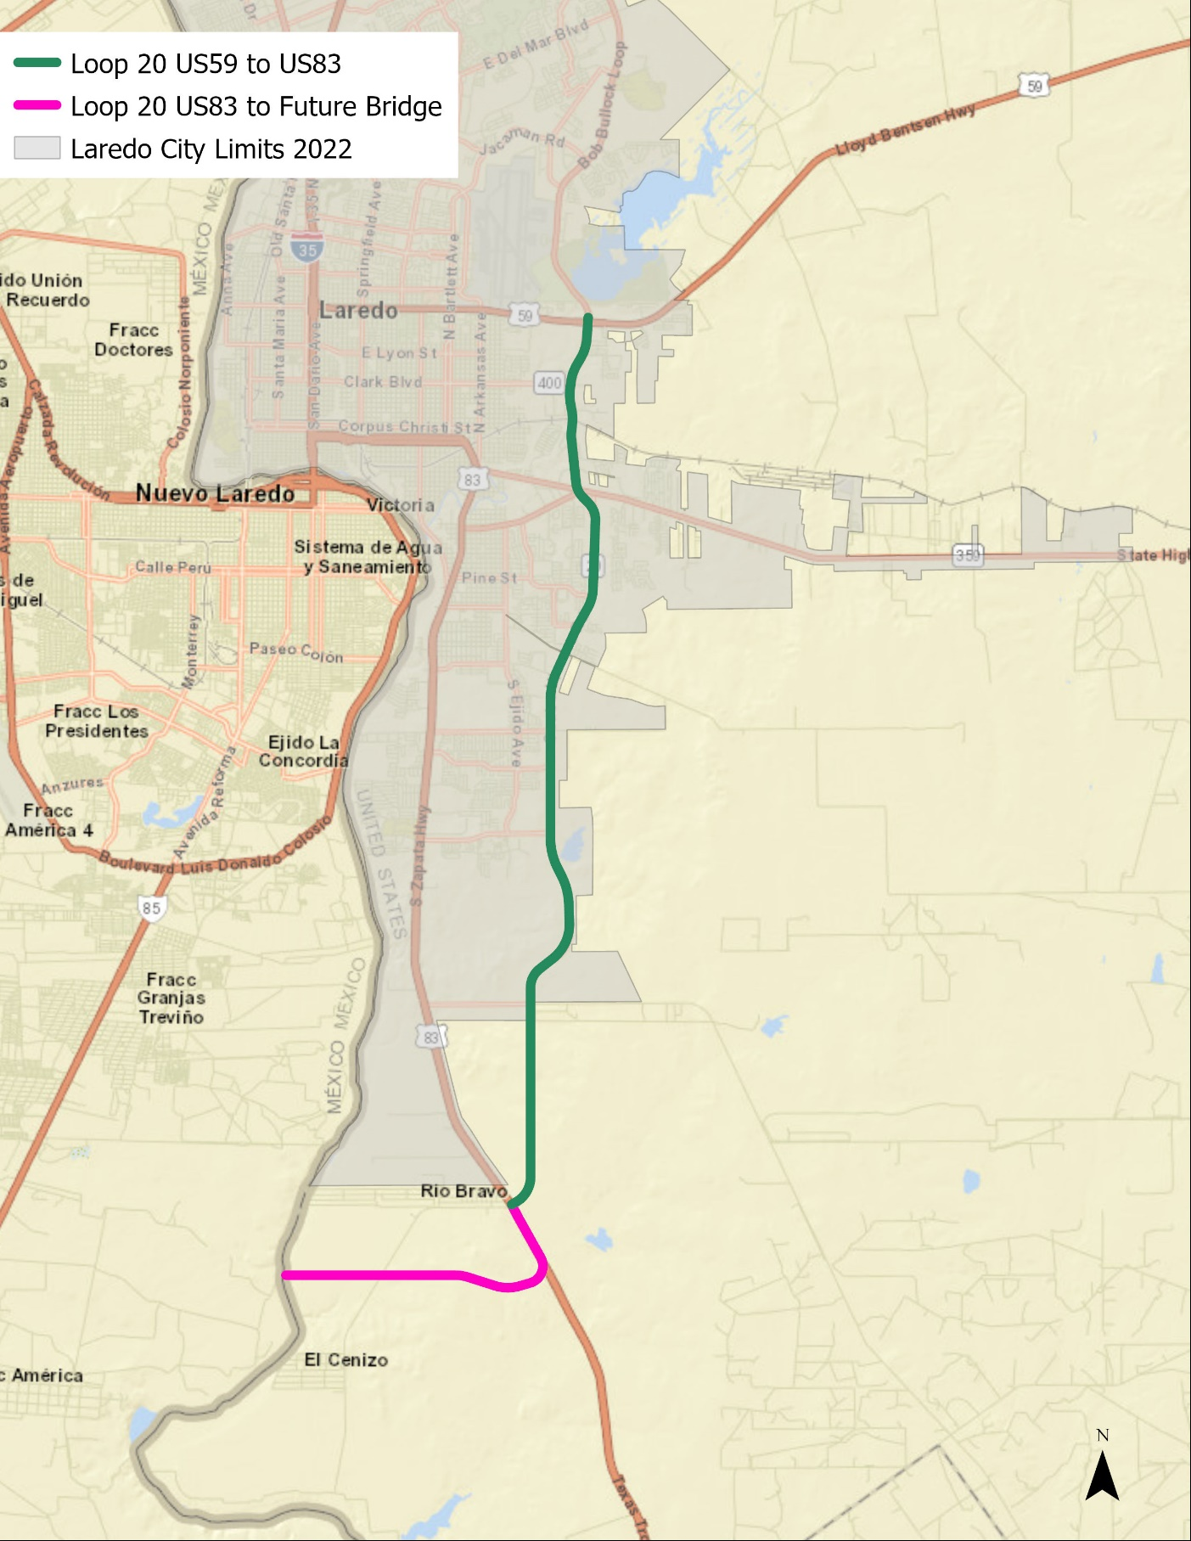
Source: TXP, Inc.
Figure 2: Loop 20 Alignment and 1-Mile TRZ Buffers
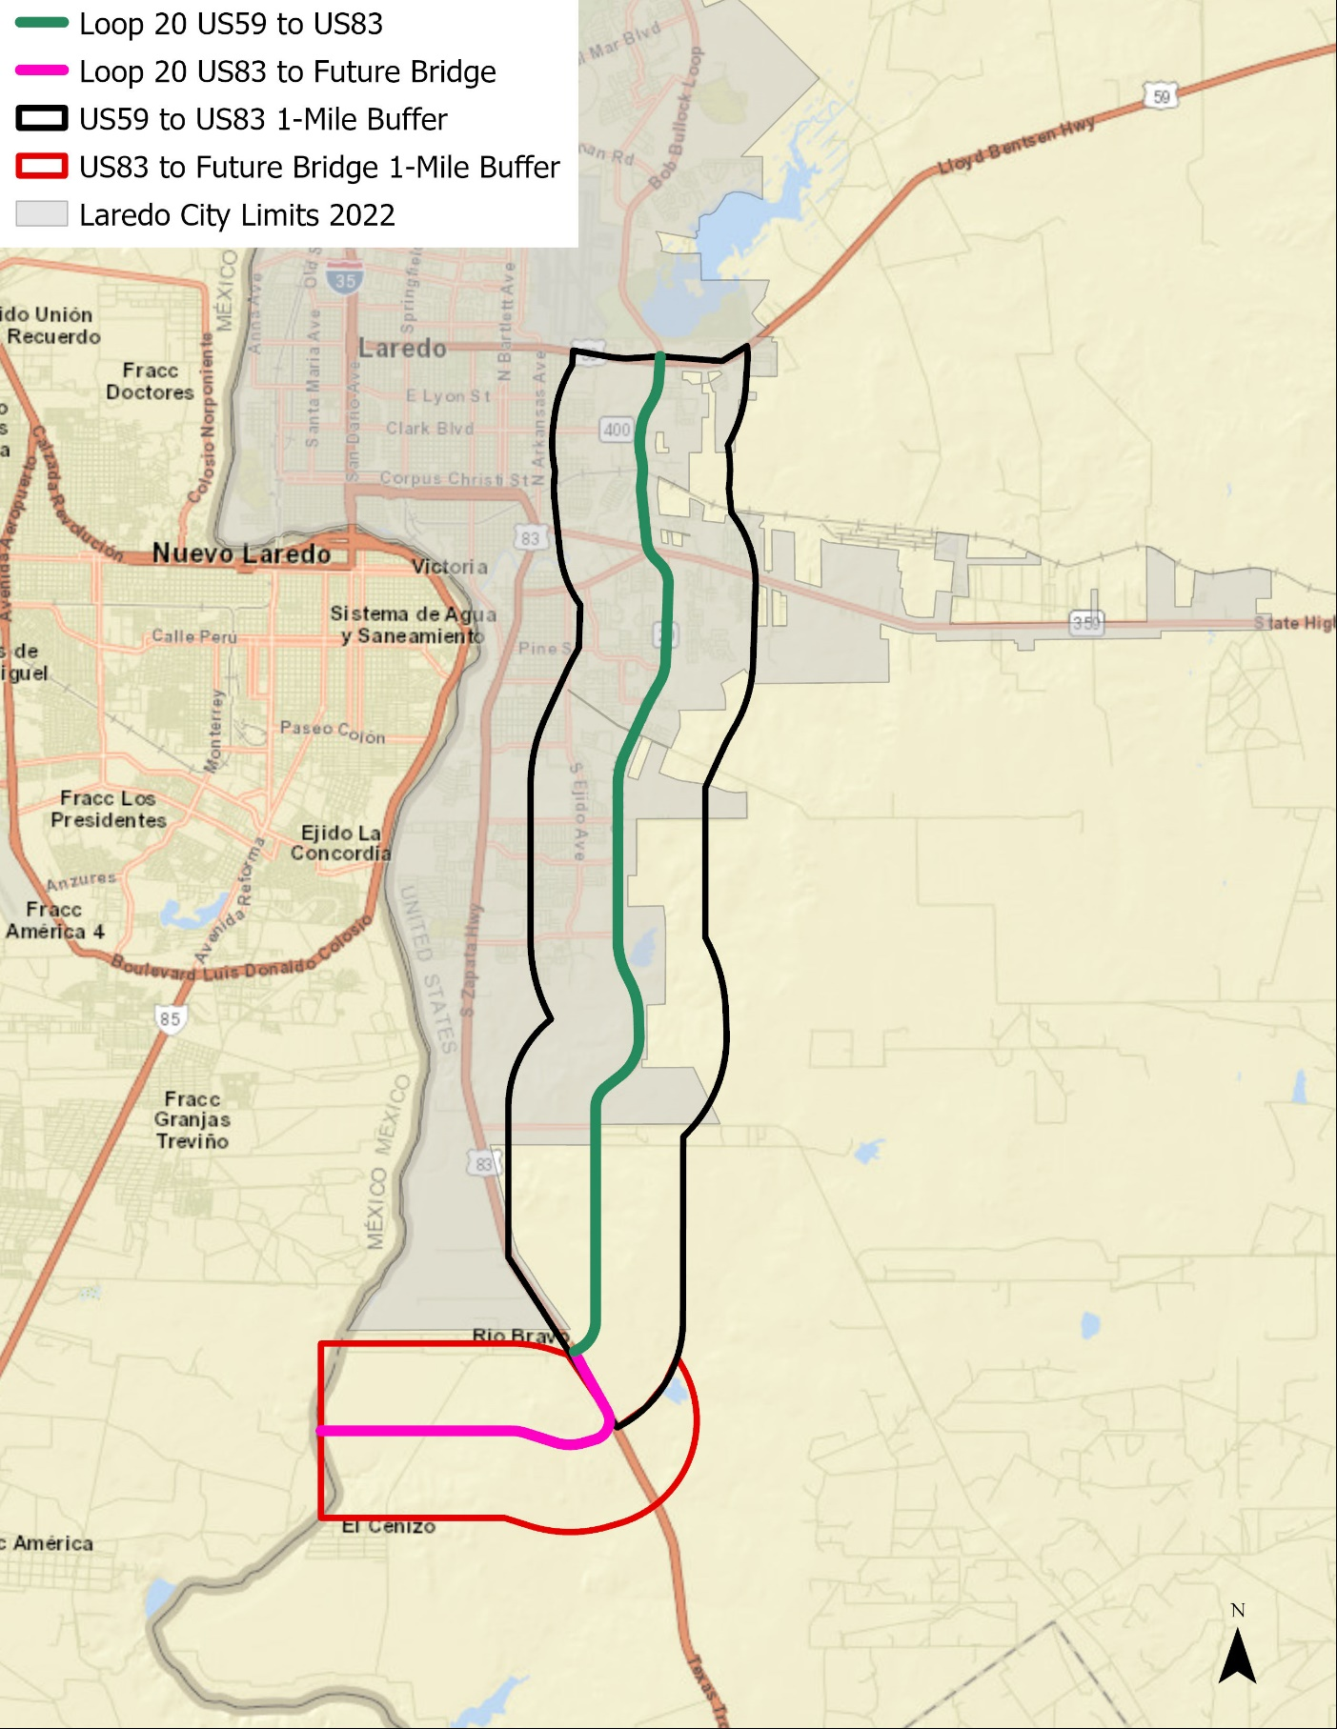
Source: TXP, Inc.
Figure 3: Preliminary Location of Crossings
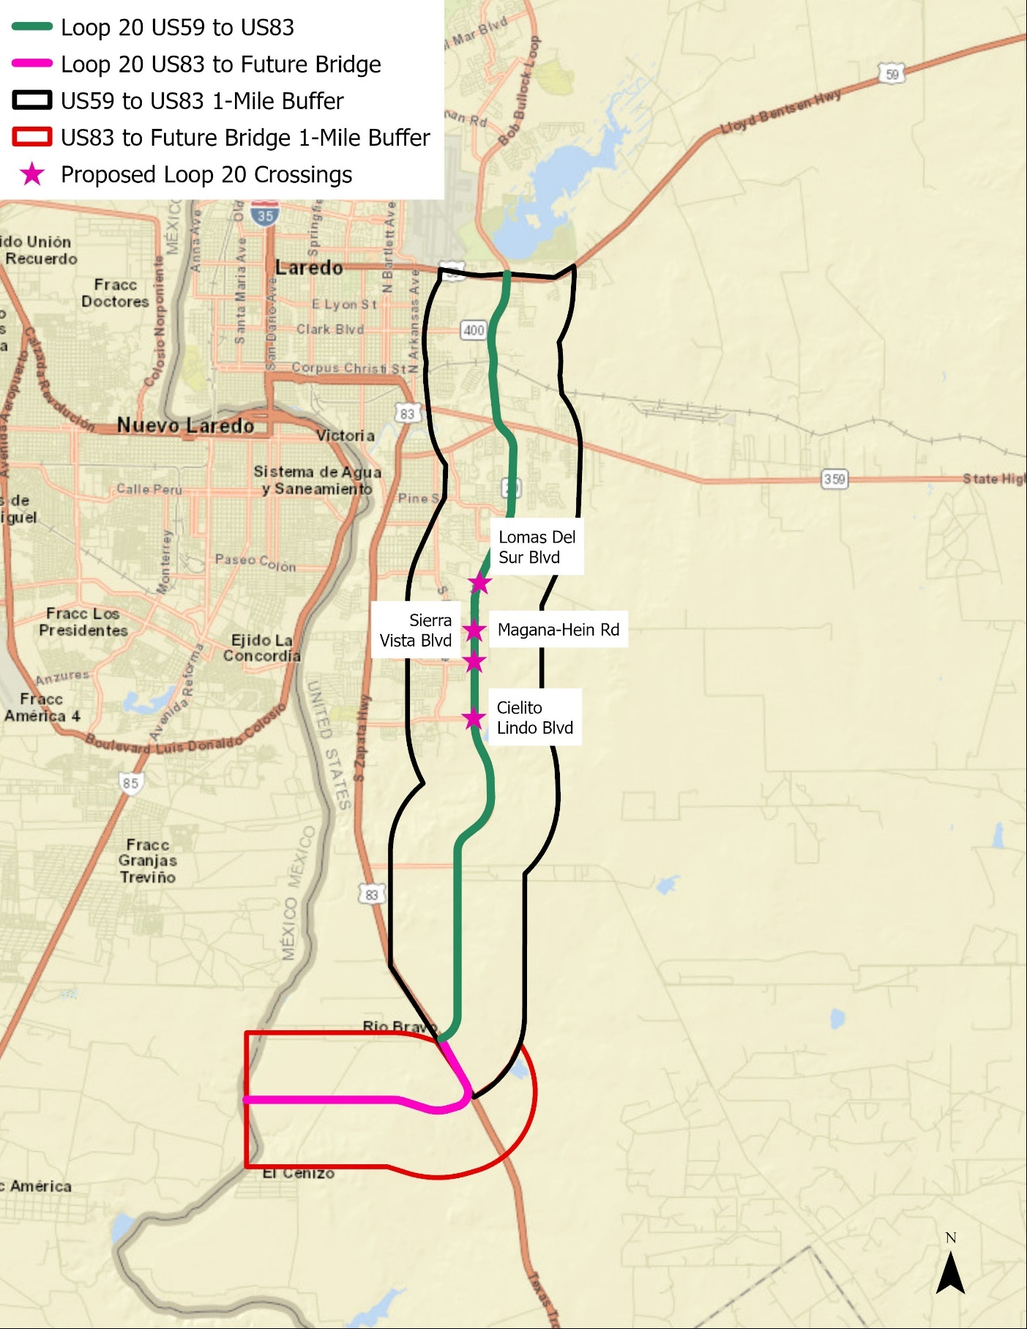
Source: TXP, Inc.
Figure 4: Loop 20 TRZ Buffers and Flood Zones
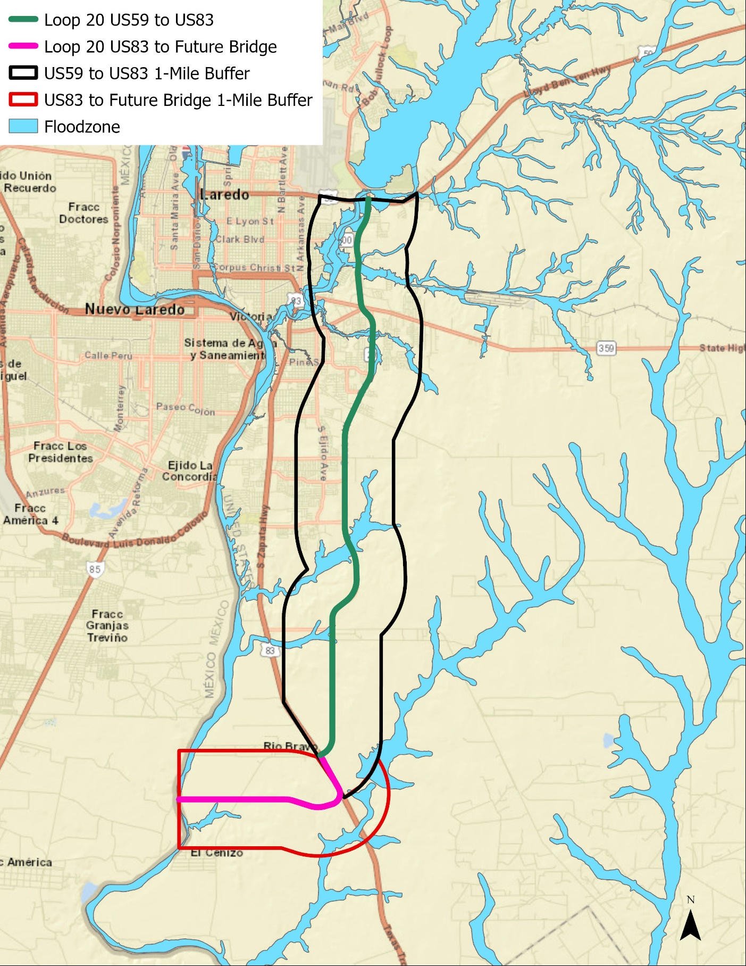
Source: TXP, Inc.
Figure 5: Loop 20 TRZ Study Area Parcels
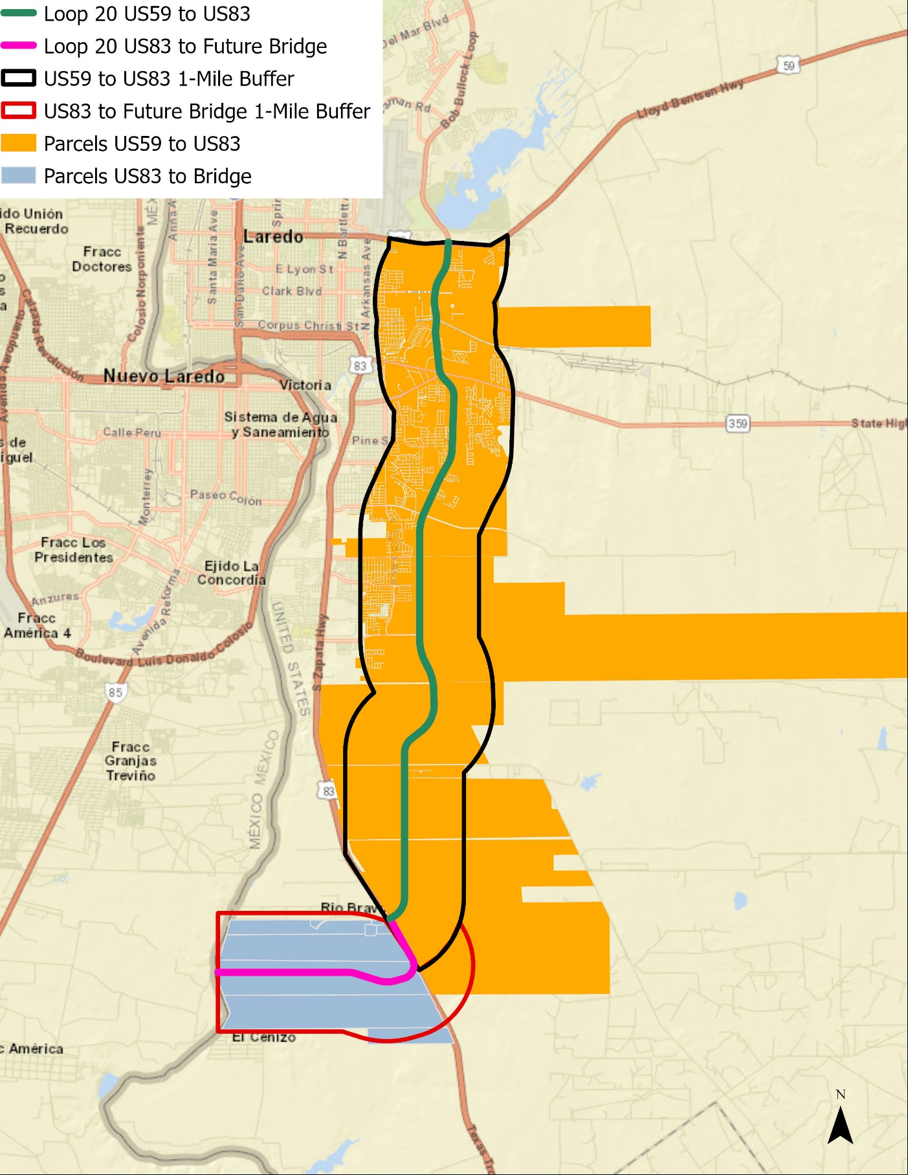
Source: TXP, Inc.
Figure 6: Undeveloped Land within Loop 20 TRZ Buffers
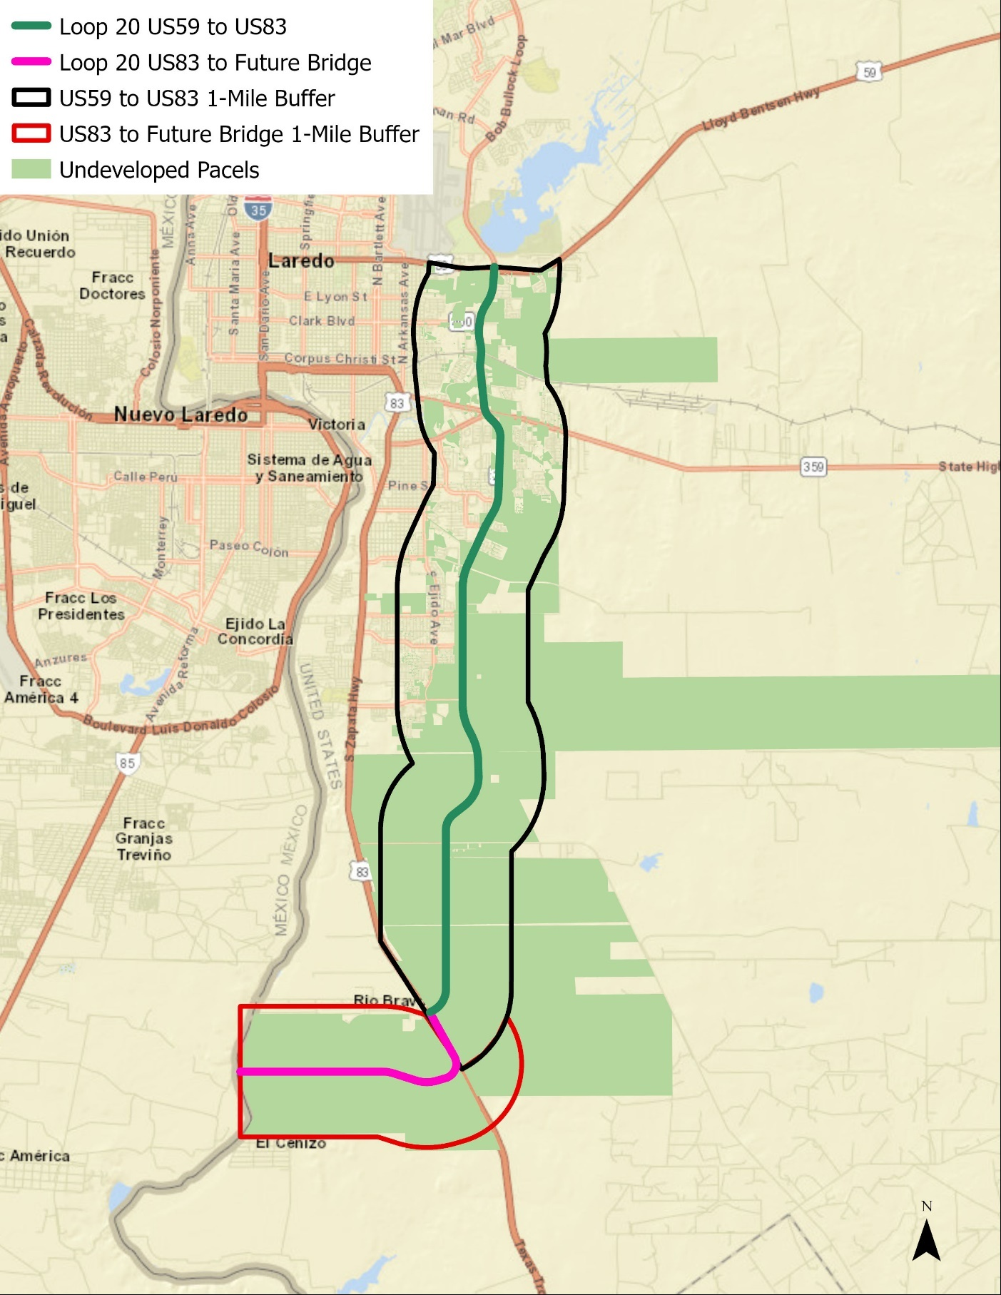
Source: TXP, Inc.
Figure 7: Large Master Plans and Future Development
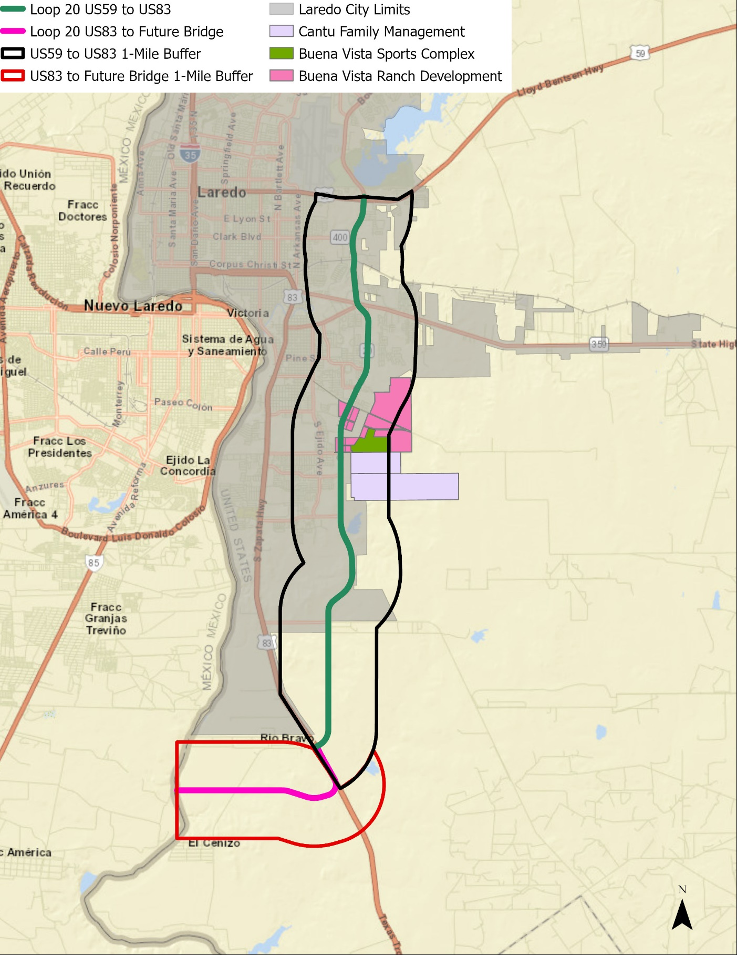
Source: TXP, Inc.

Webb County Demographic & Economic Context
Over the past few years, Webb County and the City of Laredo experienced the challenges of the COVID-19 pandemic. Unemployment rates increased and business hirings slowed. Despite the pandemic, new housing starts and home prices steadily increased. The current challenges facing the Webb County economy are rapidly rising inflation, higher interest rates, and limited labor supply. Most economists now predict a recession for 2023, with some believing the recession started in mid-2022. Given the lag in state and federal datasets, the negative effects of higher interest rates and growing inflation have yet to appear. Over the long-term, things will return to historical trends. However, growth in Webb County over the next few years might be slower.

According to the U.S. Census Bureau, Webb County is home to nearly 300,000 people. Total county population has increased 27.7 percent since 2000, or a compound annual growth rate (CAGR) of 1.5 percent. The City of Laredo is also growing at a similar pace, adding approximately 69,500 residents since 2000. In 2021, the City of Laredo represented 95.6% of total Webb County population. When the 2020 Census was released, total population for Webb County was lower than the 2019 level. TXP does not believe actual population declined, but this issue has more to do with how the U.S. Census Bureau estimates population.

Looking to the future, countywide annual population growth will likely remain between 1.0 and 1.5 percent without the development of catalytic projects. However, sub-regions of the county could grow faster or slower.

Webb County businesses now employ roughly 100,000 workers, an increase of 15,000 jobs since 2010. Total county employment expanded at a CAGR of 1.4 percent over the past 11 years. Similar to population trends, employment growth has noticeably slowed from the peak during the 1990s. Projected employment growth should move in tandem with population growth.

The real estate market in Webb County has followed overall population and employment growth. After significant growth in the 1990s through the mid-2000s, single-family home starts declined from 2006 to 2010. The market stabilized in 2011 and 2012, with new single-family home starts improving year over year. Over the past 5 years, an average of 1,200 single-family homes per year have been built in Webb County. The average cost of a new single-family home in Webb County excluding land is $166,580.

Looking towards the future, the Texas State Data Center and Moody’s predict slower population and employment growth. Population is forecast to peak in 2045 and employment growth starts to flatten in 2040.

Figure 8: Webb County Population

Source: US Census Bureau

Figure 9: Webb County Population Growth Rate

Source: US Census Bureau
Figure 10: Webb County Total Employment

Source: Texas Workforce Commission

Figure 11: Webb County Annual Employment Growth Rate

Source: Texas Workforce Commission
Table 3: Employment by Major NAICS (2021)
NAICS | Description | City of Laredo | % of Total | Webb County | % of Total
11 | Agriculture, Forestry, Fishing and Hunting | 49 | 0.1% | 101 | 0.1%
21 | Mining, Quarrying, and Oil and Gas Extraction | 325 | 0.4% | 390 | 0.4%
22 | Utilities | 73 | 0.1% | 79 | 0.1%
23 | Construction | 2,811 | 3.3% | 2,916 | 3.3%
31-33 | Manufacturing | 2,466 | 2.9% | 2,560 | 2.9%
42 | Wholesale Trade | 2,617 | 3.0% | 2,753 | 3.1%
44-45 | Retail Trade | 15,113 | 17.6% | 15,207 | 17.4%
48-49 | Transportation and Warehousing | 8,702 | 10.1% | 9,048 | 10.3%
51 | Information | 999 | 1.2% | 1,019 | 1.2%
52 | Finance and Insurance | 4,108 | 4.8% | 4,117 | 4.7%
53 | Real Estate and Rental and Leasing | 1,279 | 1.5% | 1,347 | 1.5%
54 | Professional, Scientific, and Technical Services | 5,024 | 5.8% | 5,053 | 5.8%
55 | Management of Companies and Enterprises | 368 | 0.4% | 368 | 0.4%
56 | Administrative and Support Services | 1,654 | 1.9% | 1,668 | 1.9%
61 | Educational Services | 12,621 | 14.7% | 12,861 | 14.7%
62 | Health Care and Social Assistance | 7,604 | 8.8% | 7,652 | 8.7%
71 | Arts, Entertainment, and Recreation | 824 | 1.0% | 833 | 1.0%
72 | Accommodation and Food Services | 10,455 | 12.2% | 10,461 | 12.0%
81 | Other Services (except Public Administration) | 2,847 | 3.3% | 2,883 | 3.3%
92 | Public Administration | 5,792 | 6.7% | 5,866 | 6.7%
99 | Unclassified Establishments | 282 | 0.3% | 284 | 0.3%
 | Total | 86,013 | 100.0% | 87,466 | 100.0%
Source: ESRI, Data Axle

Figure 12: Webb County Employed Civilian Labor Force

Source: Texas Workforce Commission

Figure 13: Webb County Annual Unemployment Employment Rate

Source: Texas Workforce Commission

Figure 14: Single-Family Home Building Permits in Webb County

Source: Real Estate Center at Texas A&M University

Figure 15: Average Value per Single Family Dwelling Permit in Webb County

Source: Real Estate Center at Texas A&M University
Figure 16: Single-Family Home Sales in the City of Laredo

Source: Real Estate Center at Texas A&M University; Laredo Association of REALTORS®

Figure 17: Average Value per Single Family Sold in the City of Laredo

Source: Real Estate Center at Texas A&M University; Laredo Association of REALTORS®
Figure 18: Total Building Permits for Multifamily Units in Webb County

Source: Real Estate Center at Texas A&M University

Figure 19: Average Value per Multifamily Unit in Webb County

Source: Real Estate Center at Texas A&M University
Figure 20: Webb County Population Forecasts

Source: Texas State Data Center (TSDC); Moody’s

Figure 21: Webb County Labor Force Forecasts

Source: Texas State Data Center (TSDC); Moody’s

Webb County Growth & TRZ Revenue Forecast

Revenue Forecast Scenarios
TXP has developed three revenue forecasts for a hypothetical Loop 20 TRZ. The three scenarios are described below. To be consistent with past RMA TRZ studies, TXP has projected revenue over 30 years. Because the City of Laredo and Webb County needs financial resources to provide basic services to city residents and businesses, it is unlikely they would contribute 100 percent of the future increment to a TRZ. However, to illustrate the order of magnitude a Loop 20 TRZ could generate, TXP has calculated the potential tax revenue contribution in 10 percent increments. TXP used the following assumptions in each of the forecast scenarios:

- The 2022 City of Laredo and Webb County property tax rate remained constant:
  - City of Laredo - $0.57
  - Webb County - $0.39

- The baseline values for the Loop 20 TRZ are as follows:
  - City of Laredo - $2,210,522,618
  - Webb County - $2,203,804,999

- Note, TXP does not include appreciation of existing property in the forecast. The focus of this report is future growth. If appreciation of existing property was included in the forecast, the tax revenue would be 30 percent to 40 precent higher.

- A 5.0 percent discount rate was used for the net present value (NPV) calculations.

- A 3.0 percent appreciation/inflation rate was used for residential and commercial values.

- Development around the proposed Bridge #5 would begin in 2032. TXP modeled development around Bridge #5 based on the Vallecillo Road TRZ analysis. All three scenarios use the development pattern and valuation for the US 83 to the proposed Bridge #5 segment.

- For all three scenarios, TXP used the current taxable value of commercial + industrial real property per worker of $55,388 ($2022).

- Scenario 1 uses the most recent five-year pattern of residential building permits (300 per year) within the TRZ buffer area to project household growth. TXP held the countywide ratio of population to employment constant for 30 years. This scenario assumes a new home is taxed at $190,000 ($2022).

- Scenario 2 combines the Laredo MPO TAZ forecast data with estimated home value based on stakeholder feedback. The consensus was south Laredo would begin attracting a more expensive housing product than in the past. This scenario assumes a new home is taxed at $200,000 ($2022).

- Scenario 3 uses the TXDOT Travel Demand Model. This model has lower growth through 2045. The starting residential value for new units is based on the existing 2022 average value of all existing single-family housing units in the TRZ buffer, or roughly $129,100 ($2022). This reflects uncertainty over how many mobile home units will be attracted to this area.
Table 4: City of Laredo – Scenario 1 Projected 30 Year Tax Revenue for a Hypothetical Loop 20 TRZ
Period | Year | Taxes Paid Year | 10% Allocation | 20% Allocation | 30% Allocation | 40% Allocation | 50% Allocation
0 | 2022 |  | Baseline
1 | 2023 | 2024 | $41,049 | $82,097 | $123,146 | $164,194 | $205,243
2 | 2024 | 2025 | $84,560 | $169,120 | $253,680 | $338,240 | $422,800
3 | 2025 | 2026 | $130,645 | $261,290 | $391,935 | $522,581 | $653,226
4 | 2026 | 2027 | $179,419 | $358,839 | $538,258 | $717,677 | $897,097
5 | 2027 | 2028 | $231,002 | $462,005 | $693,007 | $924,010 | $1,155,012
6 | 2028 | 2029 | $285,519 | $571,038 | $856,557 | $1,142,076 | $1,427,595
7 | 2029 | 2030 | $343,099 | $686,197 | $1,029,296 | $1,372,394 | $1,715,493
8 | 2030 | 2031 | $403,876 | $807,752 | $1,211,628 | $1,615,504 | $2,019,380
9 | 2031 | 2032 | $467,991 | $935,983 | $1,403,974 | $1,871,966 | $2,339,957
10 | 2032 | 2033 | $535,590 | $1,071,180 | $1,606,770 | $2,142,361 | $2,677,951
11 | 2033 | 2034 | $623,072 | $1,246,143 | $1,869,215 | $2,492,286 | $3,115,358
12 | 2034 | 2035 | $715,320 | $1,430,640 | $2,145,960 | $2,861,280 | $3,576,600
13 | 2035 | 2036 | $812,542 | $1,625,085 | $2,437,627 | $3,250,170 | $4,062,712
14 | 2036 | 2037 | $914,954 | $1,829,909 | $2,744,863 | $3,659,818 | $4,574,772
15 | 2037 | 2038 | $1,022,780 | $2,045,560 | $3,068,340 | $4,091,120 | $5,113,900
16 | 2038 | 2039 | $1,136,251 | $2,272,503 | $3,408,754 | $4,545,006 | $5,681,257
17 | 2039 | 2040 | $1,255,611 | $2,511,222 | $3,766,832 | $5,022,443 | $6,278,054
18 | 2040 | 2041 | $1,381,109 | $2,762,218 | $4,143,327 | $5,524,436 | $6,905,545
19 | 2041 | 2042 | $1,513,007 | $3,026,014 | $4,539,022 | $6,052,029 | $7,565,036
20 | 2042 | 2043 | $1,651,576 | $3,303,152 | $4,954,729 | $6,606,305 | $8,257,881
21 | 2043 | 2044 | $1,797,098 | $3,594,195 | $5,391,293 | $7,188,390 | $8,985,488
22 | 2044 | 2045 | $1,949,864 | $3,899,728 | $5,849,592 | $7,799,456 | $9,749,319
23 | 2045 | 2046 | $2,110,179 | $4,220,358 | $6,330,536 | $8,440,715 | $10,550,894
24 | 2046 | 2047 | $2,278,358 | $4,556,715 | $6,835,073 | $9,113,431 | $11,391,788
25 | 2047 | 2048 | $2,454,728 | $4,909,456 | $7,364,184 | $9,818,913 | $12,273,641
26 | 2048 | 2049 | $2,639,630 | $5,279,261 | $7,918,891 | $10,558,521 | $13,198,152
27 | 2049 | 2050 | $2,833,417 | $5,666,835 | $8,500,252 | $11,333,670 | $14,167,087
28 | 2050 | 2051 | $3,036,456 | $6,072,912 | $9,109,368 | $12,145,824 | $15,182,280
29 | 2051 | 2052 | $3,249,127 | $6,498,254 | $9,747,381 | $12,996,507 | $16,245,634
30 | 2052 | 2053 | $3,471,825 | $6,943,650 | $10,415,475 | $13,887,301 | $17,359,126
 | Total |  | $39,549,655 | $79,099,311 | $118,648,966 | $158,198,622 | $197,748,277
 | NPV @ 5% |  | $14,227,538 | $28,455,076 | $42,682,614 | $56,910,153 | $71,137,691
Source: TXP, Inc.

Table 5: City of Laredo – Scenario 2 Projected 30 Year Tax Revenue for a Hypothetical Loop 20 TRZ
Period | Year | Taxes Paid Year | 10% Allocation | 20% Allocation | 30% Allocation | 40% Allocation | 50% Allocation
0 | 2022 |  | Baseline
1 | 2023 | 2024 | $79,083 | $158,167 | $237,250 | $316,333 | $395,416
2 | 2024 | 2025 | $162,912 | $325,823 | $488,735 | $651,646 | $814,558
3 | 2025 | 2026 | $251,698 | $503,397 | $755,095 | $1,006,794 | $1,258,492
4 | 2026 | 2027 | $345,666 | $691,332 | $1,036,997 | $1,382,663 | $1,728,329
5 | 2027 | 2028 | $445,045 | $890,090 | $1,335,134 | $1,780,179 | $2,225,224
6 | 2028 | 2029 | $550,075 | $1,100,151 | $1,650,226 | $2,200,301 | $2,750,377
7 | 2029 | 2030 | $661,007 | $1,322,014 | $1,983,021 | $2,644,029 | $3,305,036
8 | 2030 | 2031 | $778,100 | $1,556,200 | $2,334,300 | $3,112,399 | $3,890,499
9 | 2031 | 2032 | $901,623 | $1,803,246 | $2,704,870 | $3,606,493 | $4,508,116
10 | 2032 | 2033 | $1,036,648 | $2,073,297 | $3,109,945 | $4,146,593 | $5,183,241
11 | 2033 | 2034 | $1,195,211 | $2,390,423 | $3,585,634 | $4,780,845 | $5,976,057
12 | 2034 | 2035 | $1,362,355 | $2,724,711 | $4,087,066 | $5,449,421 | $6,811,776
13 | 2035 | 2036 | $1,538,452 | $3,076,904 | $4,615,356 | $6,153,808 | $7,692,261
14 | 2036 | 2037 | $1,723,889 | $3,447,777 | $5,171,666 | $6,895,555 | $8,619,443
15 | 2037 | 2038 | $1,919,067 | $3,838,134 | $5,757,200 | $7,676,267 | $9,595,334
16 | 2038 | 2039 | $2,124,404 | $4,248,808 | $6,373,212 | $8,497,616 | $10,622,020
17 | 2039 | 2040 | $2,340,334 | $4,680,669 | $7,021,003 | $9,361,338 | $11,701,672
18 | 2040 | 2041 | $2,567,309 | $5,134,617 | $7,701,926 | $10,269,235 | $12,836,543
19 | 2041 | 2042 | $2,805,795 | $5,611,590 | $8,417,385 | $11,223,180 | $14,028,975
20 | 2042 | 2043 | $3,028,057 | $6,056,114 | $9,084,171 | $12,112,228 | $15,140,285
21 | 2043 | 2044 | $3,261,129 | $6,522,259 | $9,783,388 | $13,044,518 | $16,305,647
22 | 2044 | 2045 | $3,505,461 | $7,010,922 | $10,516,383 | $14,021,844 | $17,527,305
23 | 2045 | 2046 | $3,761,517 | $7,523,035 | $11,284,552 | $15,046,070 | $18,807,587
24 | 2046 | 2047 | $4,029,782 | $8,059,565 | $12,089,347 | $16,119,129 | $20,148,911
25 | 2047 | 2048 | $4,310,758 | $8,621,515 | $12,932,273 | $17,243,031 | $21,553,788
26 | 2048 | 2049 | $4,604,965 | $9,209,930 | $13,814,894 | $18,419,859 | $23,024,824
27 | 2049 | 2050 | $4,912,945 | $9,825,889 | $14,738,834 | $19,651,779 | $24,564,723
28 | 2050 | 2051 | $5,235,259 | $10,470,518 | $15,705,777 | $20,941,035 | $26,176,294
29 | 2051 | 2052 | $5,572,490 | $11,144,980 | $16,717,471 | $22,289,961 | $27,862,451
30 | 2052 | 2053 | $5,925,244 | $11,850,488 | $17,775,731 | $23,700,975 | $29,626,219
 | Total |  | $70,936,281 | $141,872,563 | $212,808,844 | $283,745,125 | $354,681,407
 | NPV @ 5% |  | $25,865,147 | $51,730,295 | $77,595,442 | $103,460,590 | $129,325,737
Source: TXP, Inc.

Table 6: City of Laredo – Scenario 3 Projected 30 Year Tax Revenue for a Hypothetical Loop 20 TRZ
Period | Year | Taxes Paid Year | 10% Allocation | 20% Allocation | 30% Allocation | 40% Allocation | 50% Allocation
0 | 2022 |  | Baseline
1 | 2023 | 2024 | $60,986 | $121,971 | $182,957 | $243,942 | $304,928
2 | 2024 | 2025 | $125,630 | $251,260 | $376,891 | $502,521 | $628,151
3 | 2025 | 2026 | $194,099 | $388,197 | $582,296 | $776,395 | $970,493
4 | 2026 | 2027 | $266,562 | $533,124 | $799,687 | $1,066,249 | $1,332,811
5 | 2027 | 2028 | $343,199 | $686,398 | $1,029,596 | $1,372,795 | $1,715,994
6 | 2028 | 2029 | $424,194 | $848,387 | $1,272,581 | $1,696,775 | $2,120,969
7 | 2029 | 2030 | $509,739 | $1,019,479 | $1,529,218 | $2,038,958 | $2,548,697
8 | 2030 | 2031 | $600,036 | $1,200,072 | $1,800,108 | $2,400,145 | $3,000,181
9 | 2031 | 2032 | $695,292 | $1,390,584 | $2,085,876 | $2,781,168 | $3,476,459
10 | 2032 | 2033 | $799,566 | $1,599,132 | $2,398,697 | $3,198,263 | $3,997,829
11 | 2033 | 2034 | $925,718 | $1,851,437 | $2,777,155 | $3,702,874 | $4,628,592
12 | 2034 | 2035 | $1,058,721 | $2,117,441 | $3,176,162 | $4,234,882 | $5,293,603
13 | 2035 | 2036 | $1,198,870 | $2,397,739 | $3,596,609 | $4,795,479 | $5,994,348
14 | 2036 | 2037 | $1,346,475 | $2,692,950 | $4,039,425 | $5,385,899 | $6,732,374
15 | 2037 | 2038 | $1,501,857 | $3,003,715 | $4,505,572 | $6,007,429 | $7,509,287
16 | 2038 | 2039 | $1,665,351 | $3,330,702 | $4,996,053 | $6,661,404 | $8,326,755
17 | 2039 | 2040 | $1,837,303 | $3,674,605 | $5,511,908 | $7,349,211 | $9,186,513
18 | 2040 | 2041 | $2,018,073 | $4,036,145 | $6,054,218 | $8,072,290 | $10,090,363
19 | 2041 | 2042 | $2,208,035 | $4,416,070 | $6,624,105 | $8,832,140 | $11,040,175
20 | 2042 | 2043 | $2,414,600 | $4,829,200 | $7,243,800 | $9,658,399 | $12,072,999
21 | 2043 | 2044 | $2,631,571 | $5,263,143 | $7,894,714 | $10,526,285 | $13,157,857
22 | 2044 | 2045 | $2,859,388 | $5,718,776 | $8,578,164 | $11,437,552 | $14,296,940
23 | 2045 | 2046 | $3,098,505 | $6,197,010 | $9,295,515 | $12,394,021 | $15,492,526
24 | 2046 | 2047 | $3,349,396 | $6,698,792 | $10,048,188 | $13,397,584 | $16,746,980
25 | 2047 | 2048 | $3,612,552 | $7,225,103 | $10,837,655 | $14,450,206 | $18,062,758
26 | 2048 | 2049 | $3,888,482 | $7,776,964 | $11,665,446 | $15,553,928 | $19,442,410
27 | 2049 | 2050 | $4,177,717 | $8,355,434 | $12,533,151 | $16,710,868 | $20,888,585
28 | 2050 | 2051 | $4,480,806 | $8,961,613 | $13,442,419 | $17,923,226 | $22,404,032
29 | 2051 | 2052 | $4,798,321 | $9,596,643 | $14,394,964 | $19,193,285 | $23,991,606
30 | 2052 | 2053 | $5,130,854 | $10,261,709 | $15,392,563 | $20,523,417 | $25,654,272
 | Total |  | $58,221,897 | $116,443,794 | $174,665,692 | $232,887,589 | $291,109,486
 | NPV @ 5% |  | $20,952,555 | $41,905,109 | $62,857,664 | $83,810,218 | $104,762,773
Source: TXP, Inc.

Table 7: Webb County – Scenario 1 Projected 30 Year Tax Revenue for a Hypothetical Loop 20 TRZ
Period | Year | Taxes Paid Year | 10% Allocation | 20% Allocation | 30% Allocation | 40% Allocation | 50% Allocation
0 | 2022 |  | Baseline
1 | 2023 | 2024 | $27,366 | $54,731 | $82,097 | $109,463 | $136,828
2 | 2024 | 2025 | $56,373 | $112,747 | $169,120 | $225,493 | $281,867
3 | 2025 | 2026 | $87,097 | $174,194 | $261,290 | $348,387 | $435,484
4 | 2026 | 2027 | $119,613 | $239,226 | $358,839 | $478,452 | $598,064
5 | 2027 | 2028 | $154,002 | $308,003 | $462,005 | $616,006 | $770,008
6 | 2028 | 2029 | $190,346 | $380,692 | $571,038 | $761,384 | $951,730
7 | 2029 | 2030 | $228,732 | $457,465 | $686,197 | $914,930 | $1,143,662
8 | 2030 | 2031 | $269,251 | $538,501 | $807,752 | $1,077,003 | $1,346,254
9 | 2031 | 2032 | $311,994 | $623,989 | $935,983 | $1,247,977 | $1,559,971
10 | 2032 | 2033 | $357,060 | $714,120 | $1,071,180 | $1,428,240 | $1,785,300
11 | 2033 | 2034 | $415,381 | $830,762 | $1,246,143 | $1,661,524 | $2,076,905
12 | 2034 | 2035 | $476,880 | $953,760 | $1,430,640 | $1,907,520 | $2,384,400
13 | 2035 | 2036 | $541,695 | $1,083,390 | $1,625,085 | $2,166,780 | $2,708,475
14 | 2036 | 2037 | $609,970 | $1,219,939 | $1,829,909 | $2,439,879 | $3,049,848
15 | 2037 | 2038 | $681,853 | $1,363,707 | $2,045,560 | $2,727,413 | $3,409,266
16 | 2038 | 2039 | $757,501 | $1,515,002 | $2,272,503 | $3,030,004 | $3,787,505
17 | 2039 | 2040 | $837,074 | $1,674,148 | $2,511,222 | $3,348,295 | $4,185,369
18 | 2040 | 2041 | $920,739 | $1,841,479 | $2,762,218 | $3,682,958 | $4,603,697
19 | 2041 | 2042 | $1,008,671 | $2,017,343 | $3,026,014 | $4,034,686 | $5,043,357
20 | 2042 | 2043 | $1,101,051 | $2,202,102 | $3,303,152 | $4,404,203 | $5,505,254
21 | 2043 | 2044 | $1,198,065 | $2,396,130 | $3,594,195 | $4,792,260 | $5,990,325
22 | 2044 | 2045 | $1,299,909 | $2,599,819 | $3,899,728 | $5,199,637 | $6,499,546
23 | 2045 | 2046 | $1,406,786 | $2,813,572 | $4,220,358 | $5,627,143 | $7,033,929
24 | 2046 | 2047 | $1,518,905 | $3,037,810 | $4,556,715 | $6,075,620 | $7,594,526
25 | 2047 | 2048 | $1,636,485 | $3,272,971 | $4,909,456 | $6,545,942 | $8,182,427
26 | 2048 | 2049 | $1,759,754 | $3,519,507 | $5,279,261 | $7,039,014 | $8,798,768
27 | 2049 | 2050 | $1,888,945 | $3,777,890 | $5,666,835 | $7,555,780 | $9,444,725
28 | 2050 | 2051 | $2,024,304 | $4,048,608 | $6,072,912 | $8,097,216 | $10,121,520
29 | 2051 | 2052 | $2,166,085 | $4,332,169 | $6,498,254 | $8,664,338 | $10,830,423
30 | 2052 | 2053 | $2,314,550 | $4,629,100 | $6,943,650 | $9,258,200 | $11,572,751
 | Total |  | $26,366,437 | $52,732,874 | $79,099,311 | $105,465,748 | $131,832,185
 | NPV @ 5% |  | $9,485,025 | $18,970,051 | $28,455,076 | $37,940,102 | $47,425,127
Source: TXP, Inc.

Table 8: Webb County – Scenario 2 Projected 30 Year Tax Revenue for a Hypothetical Loop 20 TRZ
Period | Year | Taxes Paid Year | 10% Allocation | 20% Allocation | 30% Allocation | 40% Allocation | 50% Allocation
0 | 2022 |  | Baseline
1 | 2023 | 2024 | $52,722 | $105,444 | $158,167 | $210,889 | $263,611
2 | 2024 | 2025 | $108,608 | $217,215 | $325,823 | $434,431 | $543,039
3 | 2025 | 2026 | $167,799 | $335,598 | $503,397 | $671,196 | $838,995
4 | 2026 | 2027 | $230,444 | $460,888 | $691,332 | $921,776 | $1,152,219
5 | 2027 | 2028 | $296,697 | $593,393 | $890,090 | $1,186,786 | $1,483,483
6 | 2028 | 2029 | $366,717 | $733,434 | $1,100,151 | $1,466,867 | $1,833,584
7 | 2029 | 2030 | $440,671 | $881,343 | $1,322,014 | $1,762,686 | $2,203,357
8 | 2030 | 2031 | $518,733 | $1,037,466 | $1,556,200 | $2,074,933 | $2,593,666
9 | 2031 | 2032 | $601,082 | $1,202,164 | $1,803,246 | $2,404,329 | $3,005,411
10 | 2032 | 2033 | $691,099 | $1,382,198 | $2,073,297 | $2,764,395 | $3,455,494
11 | 2033 | 2034 | $796,808 | $1,593,615 | $2,390,423 | $3,187,230 | $3,984,038
12 | 2034 | 2035 | $908,237 | $1,816,474 | $2,724,711 | $3,632,947 | $4,541,184
13 | 2035 | 2036 | $1,025,635 | $2,051,269 | $3,076,904 | $4,102,539 | $5,128,174
14 | 2036 | 2037 | $1,149,259 | $2,298,518 | $3,447,777 | $4,597,036 | $5,746,295
15 | 2037 | 2038 | $1,279,378 | $2,558,756 | $3,838,134 | $5,117,511 | $6,396,889
16 | 2038 | 2039 | $1,416,269 | $2,832,539 | $4,248,808 | $5,665,078 | $7,081,347
17 | 2039 | 2040 | $1,560,223 | $3,120,446 | $4,680,669 | $6,240,892 | $7,801,115
18 | 2040 | 2041 | $1,711,539 | $3,423,078 | $5,134,617 | $6,846,157 | $8,557,696
19 | 2041 | 2042 | $1,870,530 | $3,741,060 | $5,611,590 | $7,482,120 | $9,352,650
20 | 2042 | 2043 | $2,018,705 | $4,037,409 | $6,056,114 | $8,074,819 | $10,093,523
21 | 2043 | 2044 | $2,174,086 | $4,348,173 | $6,522,259 | $8,696,345 | $10,870,432
22 | 2044 | 2045 | $2,336,974 | $4,673,948 | $7,010,922 | $9,347,896 | $11,684,870
23 | 2045 | 2046 | $2,507,678 | $5,015,357 | $7,523,035 | $10,030,713 | $12,538,391
24 | 2046 | 2047 | $2,686,522 | $5,373,043 | $8,059,565 | $10,746,086 | $13,432,608
25 | 2047 | 2048 | $2,873,838 | $5,747,677 | $8,621,515 | $11,495,354 | $14,369,192
26 | 2048 | 2049 | $3,069,977 | $6,139,953 | $9,209,930 | $12,279,906 | $15,349,883
27 | 2049 | 2050 | $3,275,296 | $6,550,593 | $9,825,889 | $13,101,186 | $16,376,482
28 | 2050 | 2051 | $3,490,173 | $6,980,345 | $10,470,518 | $13,960,690 | $17,450,863
29 | 2051 | 2052 | $3,714,993 | $7,429,987 | $11,144,980 | $14,859,974 | $18,574,967
30 | 2052 | 2053 | $3,950,163 | $7,900,325 | $11,850,488 | $15,800,650 | $19,750,813
 | Total |  | $94,581,708 | $141,872,563 | $189,163,417 | $236,454,271 | $94,581,708
 | NPV @ 5% |  | $34,486,863 | $51,730,295 | $68,973,727 | $86,217,158 | $34,486,863
Source: TXP, Inc.

Table 9: Webb County – Scenario 3 Projected 30 Year Tax Revenue for a Hypothetical Loop 20 TRZ
Period | Year | Taxes Paid Year | 10% Allocation | 20% Allocation | 30% Allocation | 40% Allocation | 50% Allocation
0 | 2022 |  | Baseline
1 | 2023 | 2024 | $40,657 | $81,314 | $121,971 | $162,628 | $203,285
2 | 2024 | 2025 | $83,753 | $167,507 | $251,260 | $335,014 | $418,767
3 | 2025 | 2026 | $129,399 | $258,798 | $388,197 | $517,596 | $646,996
4 | 2026 | 2027 | $177,708 | $355,416 | $533,124 | $710,832 | $888,541
5 | 2027 | 2028 | $228,799 | $457,598 | $686,398 | $915,197 | $1,143,996
6 | 2028 | 2029 | $282,796 | $565,592 | $848,387 | $1,131,183 | $1,413,979
7 | 2029 | 2030 | $339,826 | $679,653 | $1,019,479 | $1,359,305 | $1,699,131
8 | 2030 | 2031 | $400,024 | $800,048 | $1,200,072 | $1,600,096 | $2,000,120
9 | 2031 | 2032 | $463,528 | $927,056 | $1,390,584 | $1,854,112 | $2,317,640
10 | 2032 | 2033 | $533,044 | $1,066,088 | $1,599,132 | $2,132,175 | $2,665,219
11 | 2033 | 2034 | $617,146 | $1,234,291 | $1,851,437 | $2,468,582 | $3,085,728
12 | 2034 | 2035 | $705,814 | $1,411,627 | $2,117,441 | $2,823,255 | $3,529,068
13 | 2035 | 2036 | $799,246 | $1,598,493 | $2,397,739 | $3,196,986 | $3,996,232
14 | 2036 | 2037 | $897,650 | $1,795,300 | $2,692,950 | $3,590,600 | $4,488,249
15 | 2037 | 2038 | $1,001,238 | $2,002,476 | $3,003,715 | $4,004,953 | $5,006,191
16 | 2038 | 2039 | $1,110,234 | $2,220,468 | $3,330,702 | $4,440,936 | $5,551,170
17 | 2039 | 2040 | $1,224,868 | $2,449,737 | $3,674,605 | $4,899,474 | $6,124,342
18 | 2040 | 2041 | $1,345,382 | $2,690,763 | $4,036,145 | $5,381,527 | $6,726,908
19 | 2041 | 2042 | $1,472,023 | $2,944,047 | $4,416,070 | $5,888,093 | $7,360,117
20 | 2042 | 2043 | $1,609,733 | $3,219,466 | $4,829,200 | $6,438,933 | $8,048,666
21 | 2043 | 2044 | $1,754,381 | $3,508,762 | $5,263,143 | $7,017,524 | $8,771,904
22 | 2044 | 2045 | $1,906,259 | $3,812,517 | $5,718,776 | $7,625,035 | $9,531,293
23 | 2045 | 2046 | $2,065,670 | $4,131,340 | $6,197,010 | $8,262,680 | $10,328,351
24 | 2046 | 2047 | $2,232,931 | $4,465,861 | $6,698,792 | $8,931,723 | $11,164,653
25 | 2047 | 2048 | $2,408,368 | $4,816,735 | $7,225,103 | $9,633,471 | $12,041,838
26 | 2048 | 2049 | $2,592,321 | $5,184,643 | $7,776,964 | $10,369,285 | $12,961,607
27 | 2049 | 2050 | $2,785,145 | $5,570,289 | $8,355,434 | $11,140,579 | $13,925,723
28 | 2050 | 2051 | $2,987,204 | $5,974,409 | $8,961,613 | $11,948,817 | $14,936,021
29 | 2051 | 2052 | $3,198,881 | $6,397,762 | $9,596,643 | $12,795,523 | $15,994,404
30 | 2052 | 2053 | $3,420,570 | $6,841,139 | $10,261,709 | $13,682,278 | $17,102,848
 | Total |  | $77,629,196 | $116,443,794 | $155,258,393 | $194,072,991 | $77,629,196
 | NPV @ 5% |  | $27,936,739 | $41,905,109 | $55,873,479 | $69,841,849 | $27,936,739
Source: TXP, Inc.

Conclusion
The Loop 20 improvement projects are a critical component of the City of Laredo’s overall transportation system. The project would provide improved access to thousands of acres of undeveloped land between US 59 and US 83. In addition, the Loop 20 project would support a catalytic Bridge #5 that could transform this portion of Webb County. Depending on the scenario and percent contribution – this project could generate millions of dollars.

Table 10: Summary 30 Year Tax Revenue for a Hypothetical Loop 20 TRZ (Nominal Values)
 | 10% Allocation | 20% Allocation | 30% Allocation | 40% Allocation | 50% Allocation
City of Laredo
Scenario 1 | $39,549,655 | $79,099,311 | $118,648,966 | $158,198,622 | $197,748,277
Scenario 2 | $70,936,281 | $141,872,563 | $212,808,844 | $283,745,125 | $354,681,407
Scenario 3 | $58,221,897 | $116,443,794 | $174,665,692 | $232,887,589 | $291,109,486
Webb County
Scenario 1 | $26,366,437 | $52,732,874 | $79,099,311 | $105,465,748 | $131,832,185
Scenario 2 | $47,290,854 | $94,581,708 | $141,872,563 | $189,163,417 | $236,454,271
Scenario 3 | $38,814,598 | $77,629,196 | $116,443,794 | $155,258,393 | $194,072,991
Source: TXP, Inc.

Table 11: Summary 30 Year Tax Revenue for a Hypothetical Loop 20 TRZ (NPV @ 5%)
 | 10% Allocation | 20% Allocation | 30% Allocation | 40% Allocation | 50% Allocation
City of Laredo
Scenario 1 | $14,227,538 | $28,455,076 | $42,682,614 | $56,910,153 | $71,137,691
Scenario 2 | $25,865,147 | $51,730,295 | $77,595,442 | $103,460,590 | $129,325,737
Scenario 3 | $20,952,555 | $41,905,109 | $62,857,664 | $83,810,218 | $104,762,773
Webb County
Scenario 1 | $9,485,025 | $18,970,051 | $28,455,076 | $37,940,102 | $47,425,127
Scenario 2 | $17,243,432 | $34,486,863 | $51,730,295 | $68,973,727 | $86,217,158
Scenario 3 | $13,968,370 | $27,936,739 | $41,905,109 | $55,873,479 | $69,841,849
Source: TXP, Inc.

If the City of Laredo and Webb County decide to move forward with a TRZ, the following are the next steps:

- Refine the TRZ boundary to exclude existing developed properties in the north and northwestern portion of the study area

- Collaborate with landowners on annexation within the study area so as to capture the increment from new development prior to construction beginning

- Recalculate the TRZ increment value based on the above and move forward with implementation

These projections are based on the best available datasets and information related to market conditions in Webb County. Given the high visibility of this project, for example, the substantial commitment of a few large developers could have a significantly positive impact on both the level and timing of future growth. Moreover, the financial projections make no allowance for positive spillover to the value of other properties in area as a result of new development (beyond inflation), which easily could occur. At the same time, a slowdown in development as a result of a weaker national economy, negative changes in key drivers of regional economy such as oil and gas exploration, or other unforeseen issues could materially reduce the volume of construction put in place over the next 30 years.

About TXP, Inc.
TXP is an economic analysis and public policy consulting firm founded in 1987 in Austin, Texas. Our clients have discovered that we are the firm to hire when there is not an immediate, obvious, or simple solution to their economic or public policy challenge. In addition to drawing on the expertise of our firm members, we regularly partner with urban planning, engineering, and public policy firms to put together teams uniquely suited to our clients' needs.

TXP offers a full-range of economic analysis and forecasting services to public and private clients. The firm specializes in applying focused primary research to enhance secondary data. TXP offers a number of other services to clients, including periodic reports highlighting economic trends in regional economies and presentations to a range of stakeholders. TXP currently serves as economist-on-retainer for a number of high-profile private and public sector clients throughout Texas.

As economic development policy becomes increasingly standardized, differentiating one community from the next becomes more difficult. TXP takes a more customized approach. Unlike traditional community and economic development plans that rely heavily on historical demographic data and current industry concentrations or clusters, TXP believes that integrating targeted business recruitment with land use planning and cultural vitality offers the best opportunities for long-term growth.

TXP has successfully helped clients manage the balance between economic development, land use planning, and infrastructure development to ensure overall community prosperity. Our team provides in-depth analysis on the connection between tax base enhancement and service cost reduction, and works with communities, state agencies, local governments, universities, and developers to facilitate growth and redevelopment.

TXP, Inc.
1310 South 1st Street, Suite 105
Austin, Texas 78704
(512) 328-8300 phone
www.txp.com

Legal Disclaimer

TXP reserves the right to make changes, corrections and/or improvements at any time and without notice. In addition, TXP disclaims any and all liability for damages incurred directly or indirectly as a result of errors, omissions, or discrepancies. TXP disclaims any liability due to errors, omissions or discrepancies made by third parties whose material TXP relied on in good faith to produce the report.

Any statements involving matters of opinion or estimates, whether or not so expressly stated, are set forth as such and not as representations of fact, and no representation is made that such opinions or estimates will be realized. The information and expressions of opinion contained herein are subject to change without notice, and shall not, under any circumstances, create any implications that there has been no change or updates.

